**Maintenance page enable & disable**

Login to <https://control.akamai.com/homeng/view/main> with your credentials.

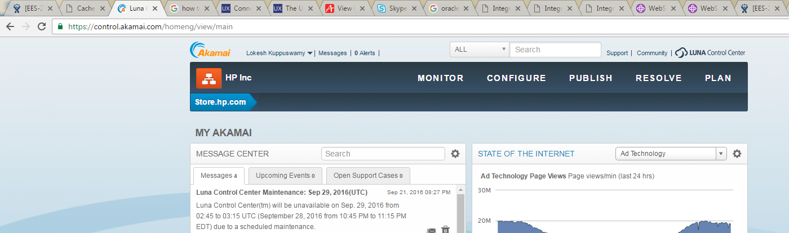

Then click on CONFIGURE and “cloudlets policy manager”

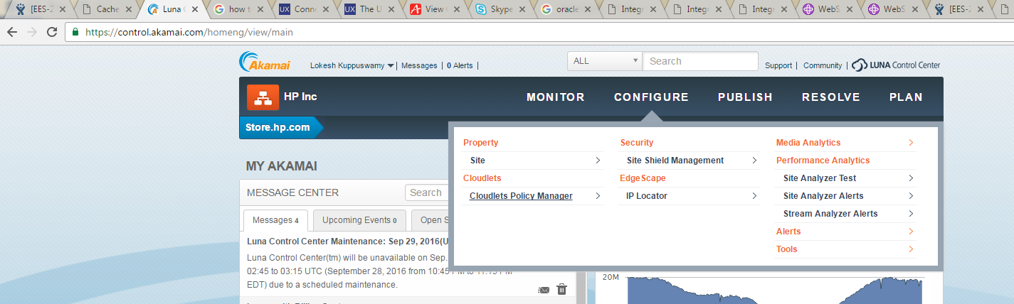

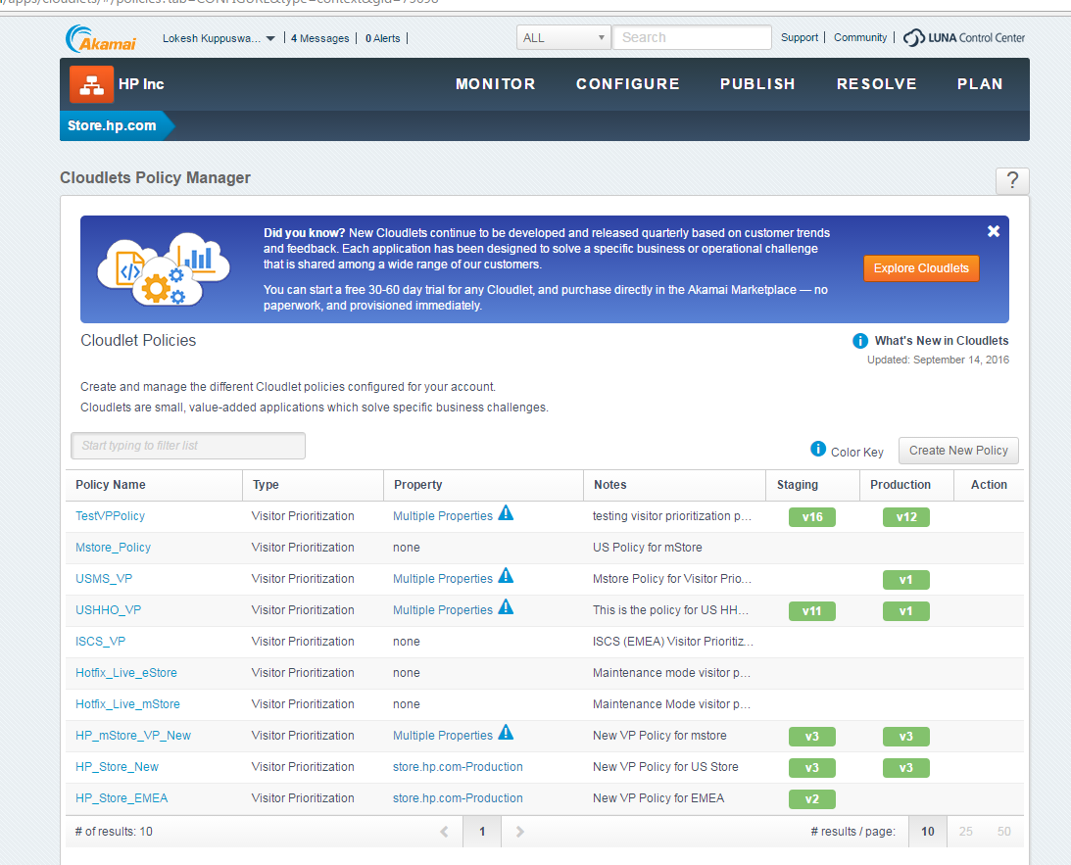

“[HP_Store_New](https://control.akamai.com/apps/cloudlets/)” is for estore

“[HP_mStore_VP_New](https://control.akamai.com/apps/cloudlets/)” is for mstore

Do not use anyother options above

Click on [HP_Store_New](https://control.akamai.com/apps/cloudlets/) for enabling/disabling maintenance page.

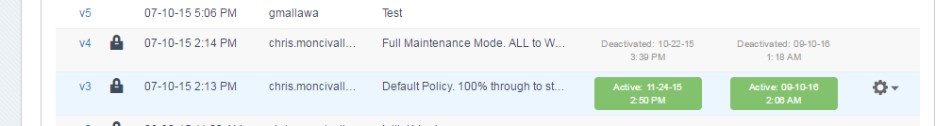

Currently version 3 is active for production.

**V3 – is 100% site traffic**

**V4 – is 100% to maintenance page.**

To enable maintenance page click on the settings icon on the right corner of the V4

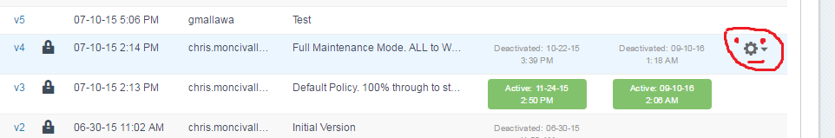

And click on activate version.

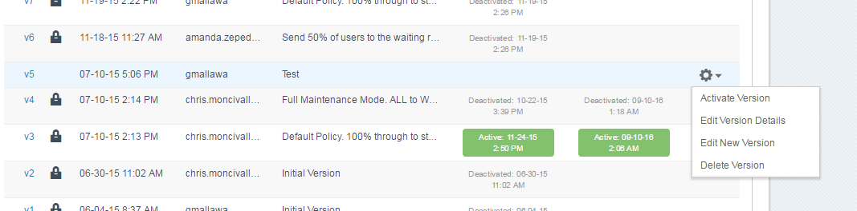

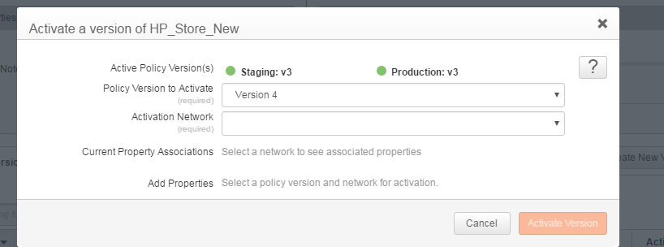

Select version 4 from the drop down

Select production from the Acticvation network

Click on Activate version.

**To disable the maintenance page, click on the settings icon on V3—activate version-version3-production-activate version.**